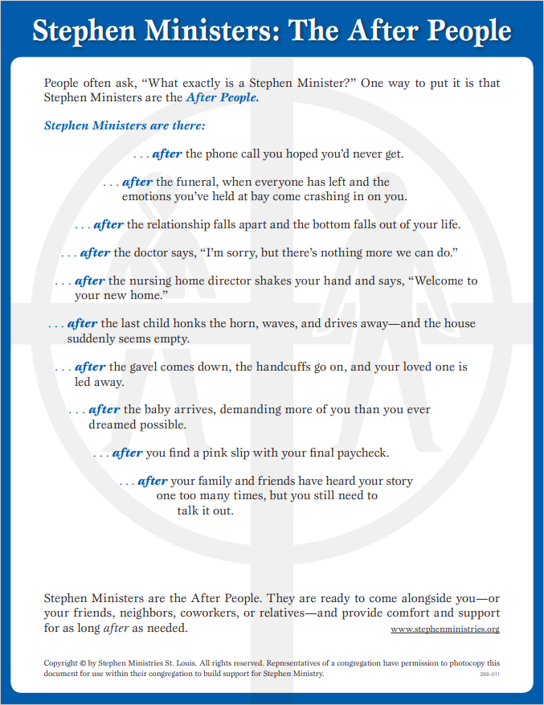
Stephen Ministers care for people who are: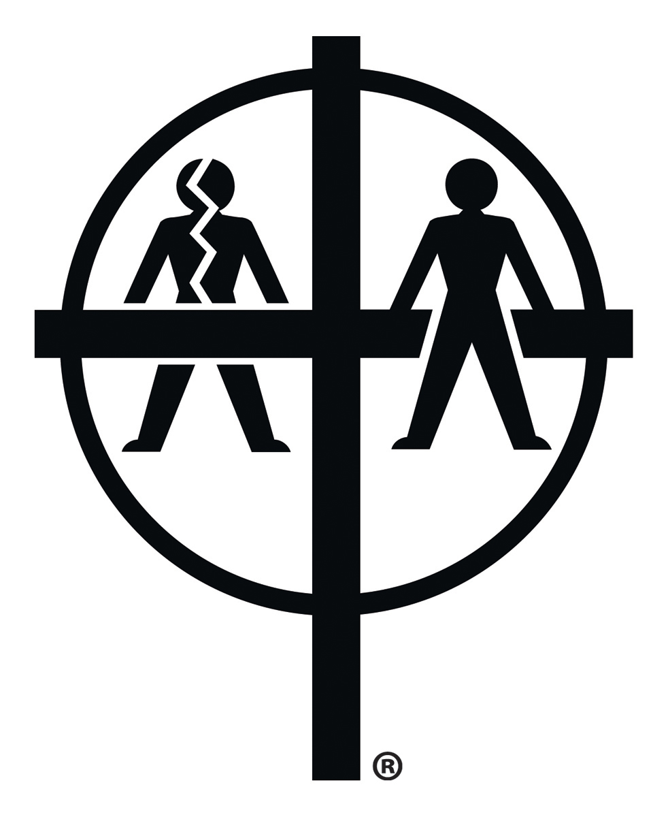

- Bereaved
- Terminally ill
- Separated or divorcing
- Hospitalized or convalescing
- Single parents
- Experiencing vocational stresses, such as relocation, reorganization, termination, or starting a new job
- Refugees
- Students living away from home
- Residents of long-term care facilities
- Inmates of jails, prisons, or detention centers
- Caretakers of ill or disabled persons
- Adjusting to family changes such as remarriage, institutionalization of a family member, or new baby
- Parents whose children present exceptional challenges
- Newlyweds
- Homebound
- Coping with infertility
- Entering or reentering the job market
- Retiring
- Dealing with adoption issues
- Victims of crime
- New residents of a community
- Preparing for professional Christian service
- Chronically ill, in pain, or disabled
- Survivors of natural disasters or other catastrophes
- In the military

